Access to Higher Education







Workbook for:

Introduction to Psychology (PSY 2)
and Human Memory (PSY 1)

Introduction

This workbook describes what we are going to cover in the first half-term of this course and contains some home-works that will help you complete one of the modules later in the course.

This course is taught on Monday from 09.30 - 12.00md
12.30 - 15.00 Wednesday 09.30 – 12.00md
12.30 – 15.00

All work for psychology is in the form of portfolio evidence of learning. You will be required to provide evidence of your learning by completing an assignment consisting of four pieces of work for each of the four psychology units. A variety of assessment methods will be used; including essays, reports and an exam.

The convention for handing work is as follows. There is a hand in date, if you hand in work at this time it will be marked and returned to you after a selection of student work has been second marked.

If further work is needed this will be pointed out and amendments can be made by the second deadline date. Any late work or work needing a second resubmission will be capped at a pass mark (or even fail) unless the extension process is followed. All work must be handed in (as hard copy) with a cover sheet, contents pages and information for the examiners. These are provided on Moodle (VLE) and can be downloaded and treated as a ‘live’ document.

The Hand in Documents contains a ‘learning point’ sheet enclosed use this to ensure that all criteria are covered and you have completed everything needed for hand in. You will have a checklist or be given advice as to what this is. When the work is of a satisfactory nature the final column is initialled by your teacher with a date of completion.

We will work through most of the first psychology unit during the lesson and have time to complete parts of the unit during lesson time. Photocopies of textbooks and most of the material will be provided.

The first part of the course will look at what psychology is about and also at the methods used by psychologists when investigating psychological phenomenon. We examine these methods and the nature of the scientific approach to investigating behaviour and the mind.

Overview of first part of the Access Course

Week no./week beginning | Topic
1. 07/09/20 | Induction Week: Tuesday 8 September and Thursday 10 September (TBC)
2. 14/09/20 | Introduction to Psychology
3. 21/09/20 | Measuring Psychological Phenomena
4. 28/09/20 | Short-Term Memory (Hand Out PSY 1)
5. 5/10/20 | Long Term Memory
6.12/10/20 | Forgetting and Improving Memory
7. 19/10/20 | Tutorial to write up PSY 1 for Hand-in after Half-term  FRIDAY 23 OCTOBER: STAFF DEVELOPMENT DAY – college closed
Half term | w.c. 26.10.20
8. 2/11/20 | Research Methods week 1 The Experiment (Hand in PSY1) (Hand out PSY2)
9. 09/11/20 | Research Methods Week 2
10. 16/11/20 | Behavioural approach
11. 23/11/20 | Psychoanalytic Approach
12. 30/11/20 | Looking at Ethics
13. 07/12/20 | Tutorial – Bring everything together for assignment
14. 14/12/20 | Catch up week, no formal lessons. I am here for advice Monday and Wednesday. Hand in PSY 2 by 3.00pm Wed 16 December  COLLEGE CLOSED: THURSDAY 17 DECEMBER (STAFF DEVELOPMENT)  COLLEGE CLOSED: FRIDAY 18 DECEMBER (STAFF CHRISTMAS PARTY)
Christmas Holiday | w.c. 21/12/20

Lesson One

What is Graham’s Email?

He is Famous For..?

What are the Ground Rules for this Class?

Is there a special rule for psychology?

List some things that YOU think psychology is about

List some of the areas that psychology covers

List some jobs psychologist do

What is science?

Now think about the practical approaches of research in the Social Sciences

How might a psychologist study the life and experiences of Access to HE students?

What methods might be used?

Think about the advantages and disadvantages of each method?

To be completed as we go along in the next few weeks.

Section 1

Using note format, or using a list of bullet points; list the key features, an example of, and the advantages and disadvantages of the research methods listed below:

Psychological methods

Method | Advantages | Disadvantages | Applications
Covert Observation
Overt Observation
Experiment
Case Study
Focus Group
Surveys and questionnaires
Structured Interview
Unstructured Interview

Week 2 Measuring Psychological Attributes

Intelligence and IQ

What do you think Intelligence is?

Try these questions, individually

A) You buy 3 bars of chocolate at 29p each and 10 stamps at 33p each. How much change do you get from £5?

B) Which of these are spelt correctly? Fulfiled Inoculation Embarass
Hypocracy Superseded Desicate

C) Find the next two numbers in these series:
i) 1 3 6 10 15
ii) 2 4 3 9 4

D) Find the odd one out in each series:
i) Peach Banana Tomato Plum
ii) Knife Plate Scissors Fork

E) You have to find a suitable new flatmate as quickly as possible.
What sequence of actions would you take?

F) How many uses can you think of for a dustbin lid?
World’s Shortest IQ test

Answer 1

Answer 2

Answer 3

Why does this test work?

Lecture Notes

What does IQ mean?

Why is it measured the way it is?

What is g?

This relies on the understanding of a statistical method known as correlation. You have probably heard of the word before. The idea is that often two variables are related; height and weight for instance. Taller people generally weigh more than short people, but there is variation. If the two variables moved together exactly then they would have a correlation of one. In social sciences 0.4 is considered pretty good evidence of a relationship.

How many factors does Turnstone think there are?

Is intelligence likely to be a benefit in term of reproductive success?

Who thinks not?

How many intelligences does Howard Gardener think there are?

Existential intelligence is the ability to ponder big questions, why are we here etc. The sort of questions that arise after too much drinking at two in the morning

Robert Sternberg says there are how many areas of intelligence?

What is the main area of research supporting this hypothesis?

What is meant by Emotional Intelligence?

Who is the main proponent of this theory?

What do you think of intelligence tests?

Discussion points that you might want to remember

Limited content

Restricted answers

Educationally biased

Are people who are quicker more intelligent?

Are they culturally biased?

There is a book by Herrnstein and Murray called “The Bell Curve” (1993) that highlights racial differences found in the American Public. There are now books about this book!

What others have arisen during the discussion?

Do you think you were born with this level of intelligence or has your level of intelligence changed over time? Some Psychologists argue that many aspects can be measured. This is called the Psychometric Approach. Early proponent of this approach was Hans Eysenck (1916-1997). He argued that the personality is made of different factors. He used a wide sample of people and questions and developed the questionnaire shown below. We will have a go at doing this and we can discuss the results.

What words do we use to describe personality?

Do you think personality fixed?
The Eysenck Personality Questionnaire (EPQ)

1 | Do you have many different hobbies? | YES | NO
2 | Does your mood often go up and down? | YES | NO
3 | Are you a talkative person? | YES | NO
4 | Do you ever feel "just miserable" for no reason? | YES | NO
5 | Are you rather lively? | YES | NO
6 | Do you often worry about things you should not have done or said? | YES | NO
7 | Can you usually let yourself go and enjoy yourself at a lively party? | YES | NO
8 | Are you an irritable person? | YES | NO
9 | Do you enjoy meeting new people? | YES | NO
10 | Are your feelings easily hurt? | YES | NO
11 | Do you tend to keep in the background on social occasions? | YES | NO
12 | Do you often feel "fed-up"? | YES | NO
13 | Do you like going out a lot? | YES | NO
14 | Are you often troubled about feelings of guilt? | YES | NO
15 | Do you prefer reading to meeting people? | YES | NO
16 | Would you call yourself a nervous person? | YES | NO
17 | Do you have many friends? | YES | NO
18 | Are you a worrier? | YES | NO
19 | Would you call yourself a happy-go-lucky? | YES | NO
20 | Do you worry about awful things that might happen? | YES | NO
21 | Do you usually take the initiative in making new friends? | YES | NO
22 | Would you call yourself tense or "highly-strung"? | YES | NO
23 | Are you mostly quiet when you are with other people? | YES | NO
24 | Can you easily get some life into a rather dull party? | YES | NO
25 | Do you worry about your health? | YES | NO
26 | Do you like telling jokes and funny stories to your friends? | YES | NO
27 | Do you like mixing with people? | YES | NO
28 | Do you suffer from sleeplessness? | YES | NO
29 | Do you nearly always have a "ready answer" when people talk to you? | YES | NO
30 | Have you often felt listless and tired for no reason? | YES | NO
31 | Do you like doing things in which you have to act quickly? | YES | NO
32 | Do you often feel life is very dull? | YES | NO
33 | Do you often take on more activities than you have time for? | YES | NO
34 | Do you worry a lot about your looks? | YES | NO
35 | Have you ever wished that you were dead? | YES | NO
36 | Can you get a party going? | YES | NO
37 | Do you worry too long after an embarrassing experience? | YES | NO
38 | Do you suffer from "nerves"? | YES | NO
39 | Do you often feel lonely? | YES | NO
40 | Are you easily hurt when people find fault with you or the work you do? | YES | NO
41 | Do you like plenty of bustle and excitement around you? | YES | NO
42 | Are you sometimes bubbling over with energy and sometimes very sluggish? | YES | NO
43 | Do other people think of you as being very lively? | YES | NO
44 | Are you touchy about some things? | YES | NO

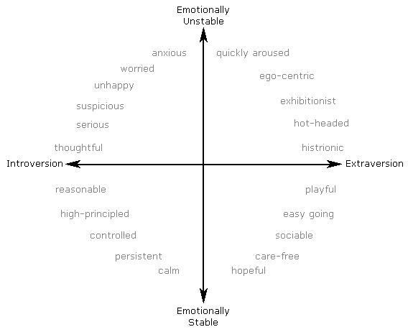

Plot your score by going along the Extraversion line your score and up the emotionally unstable line your score. Same as a map coordinate.

Week 3 Memory

One Approach to Psychology - Cognitive Psychology Memory
Cognitive approach looks at how we make sense of the world.

Is there a big assumption?

What is memory?

Stages of memory

Big Words:

Iconic

Auditory

Echoic

Haptic

Olfactory (Gustatory)

Semantic

Stages of Memory – Sensory Memory

What did Sperling (1960) find?

We remember some things and not others – is it remembering or lack of retrieval?

Are there different bits of memory?

Practical Demonstration – Memory test and hand out needed

STM is very limited - Millers (1956) Magical Number

Did anyone notice the Primacy and Recency Effect

Implication is that there are different bits of memory

Short Term Memory

Limits to Short Term Memory

What is Chunking?

Write your letter sequence here:

What is the secret?

Can you think of some chunked information?

The Atkinson-Shiffrin multi-stage model

This model is known as the two-stage model or multi-store model

(Some textbooks add sensory or iconic memory
Long-Term Memory

Cue dependency

What does this mean?

Linking to other memories can you think of things that go together easily?

State dependent recall

Using this information, what advice would we give to somebody studying for an exam?

Flashbulb Memory - What is this?

Does evidence support this?

Week 4

Long Term Memory and Alternative Views of Memory

What do you remember after the smelling exercise?

What films did you discuss? Write down some bullet points here

Was this information data? Or did you think of emotional aspects to the film/first day at college?

What problems are there with the Atkinson-Shiffrin Model?

What is good about the model?

Everything makes sense so far – Level 3 thinking is about looking deeper and asking questions

Alternative Models for Memory Alternatives to LTM model

Craik and Lockhart (1972) Levels of Processing.

How can we use this knowledge to help us with the course?

Collins and Quillian (1969) Hierarchical Network.

Working Memory Model – alternative to STM model

What is a Central Executive?

What did Hitch and Baddeley (1971) find

Can we do two tasks at the same time with the same ability as we could do one?

The STM has different components. What does the study with KF show.

What do know about case studies?

How can we improve our memory?
Memory Exercises
Have you seen in the news or TV people who can remember vast amounts of meaningless information? There are people who can remember the order of packs of cards, useful when playing Black Jack (pontoon or 21s). This is why ‘The House’ have two or three decks of cards in the dealer’s shoe.

Are there tricks to this?

Do you use Mnemonics to remember things?

For colours of a rainbow

E.g. Richard Of York Gave Battle In Vain (Red, Orange, Yellow, Green, Blue, Indigo, Violet)

Can you think of others?

Another common method is called the Method of Loci. This is where a list is remembered by imaging where they might lie in an imaginary room, street or scene of some sort. I use this method in the supermarket, if I don’t make a list. I go up and down each aisle and think of things in my kitchen that I might need. This is why Tesco has all my money!

Try it with this list of words. Look at the street below, it is called memory lane (the version I have here is American). You can use the road on which you live to do this.

Look at this list of words and, in your head, place them somewhere in memory lane.

dollar | jade | nurse | Cabbage | word
Ladle | Air | Camel | Ant | Iron
Golf | Berry | Nut | Trout | Boat
Hour | Leaflet | Mirror | Board | Queen
beer | scissors | cello | Sand | canvas
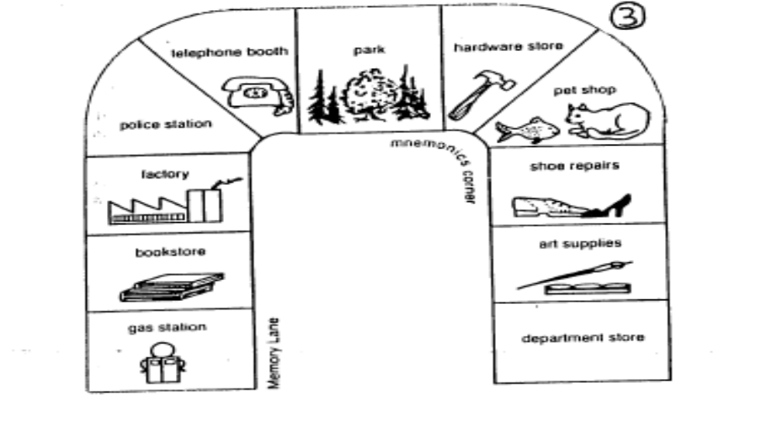
Making up a story around words you need to learn.

Try making up a story using these words:

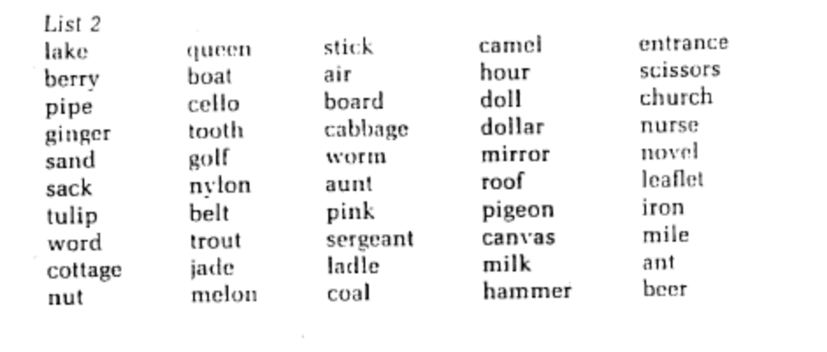

Class discussion: do you have personal tricks to remember things and what can we do to improve our learning?

Week 5 – Forgetting – by the end of the lesson you must be able to explain two theories

Group Work – what theories of forgetting are there?

Decay

Repression

Cue Dependent Recall

Interference

Can you find evidence to support any of these theories?

What are the implications of these theories for our learning, care of dementia patients, eye witness testimony ?

Week 6

Tutorial Week – Are we confident in this knowledge:

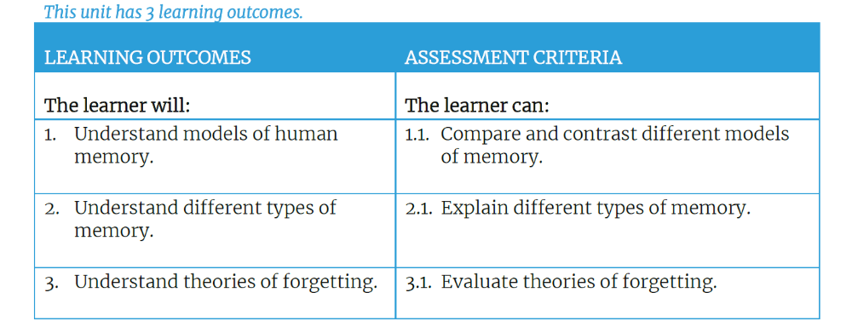

Week 8 Experiments and Ethics Start PSY2

What is meant by the scientific method?

How does the scientific process work?

Paradigm

Theory

Hypothesis

Null-Hypothesis

Variables

Dependent variable

Independent variable

Extraneous or confounding variable

Real research: why do we find certain people attractive?

https://www.youtube.com/watch?v=oKP0qnqcY0w

What is the paradigm?

The theory?

The hypothesis?

What would be the null-hypothesis?

What is the measure used?

How is this data collected?

If you were doing this experiment, what do you think you would have to control for?

Sweaty T-Shirts and Human Mate Choice:
Maybe it's not similar interests, horoscope signs, looks, or proximity that make women and men fall in love. According to evolutionary scientists, when people throw up their hands and say "it was just chemistry," they may be on to a fundamental factor in mate choice.
Subtle chemical signals, or pheromones, have long been known to draw pairs together within the same species, and for a specific reason. In mice, for example, experiments showed that pheromones acted as attractants between males and females who were genetically similar except that they differed in a certain type of immune system gene. That difference is actually a survival benefit: The combination of two individuals' different MHC (major histocompatibility locus) genes gives their offspring an advantage in beating back disease organisms.
So the mice could smell a genetic difference. But could modern humans, who aren't known for a particularly good sense of smell, also make that distinction?
In the first "sweaty T-shirt" experiment, a Swiss zoologist, Claus Wedekind, set up a test of women's sensitivity to male odors. He assembled volunteers, 49 women and 44 men selected for their variety of MHC gene types. He gave the men clean T-shirts to wear for two nights and then return to the scientists.
In the laboratory, the researchers put each T-shirt in a box equipped with a smelling hole and invited the women volunteers to come in, one at a time, and sniff the boxes. Their task was to sample the odor of seven boxes and describe each odor as to intensity, pleasantness, and sexiness.
The results were striking. Overall, the women preferred the scents of T-shirts worn by men whose MHC genes were different from their own.
The experiment did not test men's perceptions of female scents, but the results certainly suggest that evolution has provided humans, not just mice, with a transmitter and receiver for genetic information that could influence mate choice.
And all this even before the first date!

Ethical considerations

Can scientists just do experiments?

Who is in charge of guiding psychological experiments?

Who else might a researcher ask for advice?

What are the main considerations for ethical experiments with humans?

Consider for the tee shirt experiment how we could ask participants for their;

Consent to take part – what do they have to do and what information do they provide?

Do we need to employ deception?

What do we tell participants (briefing)?

What do we tell them after (debriefing)?

Can we give them a right to withdraw?

How would we deal with confidentiality/anonymity?

Week 9 Methods of Research

What is Quantitative Data?

What is Qualitative Data?

In what ways are data gathered?

Revisit the table on page 6

Week 10 Behavioural Approach

(Section 1) Using your textbooks to make brief notes on the following:

a: Pavlov’s research using dogs

b: Skinner’s research using the Skinner box and a variety of animals

c: Watson’s research using Little Albert

(Section 2) Briefly explain the following terms:-

a: unconditioned stimulus (US)

b: unconditioned response (UR)

c: neutral stimulus (NS)

d: conditioned stimulus (CS)

e: conditioned response (CR)

(Section 3) Briefly explain the following themes:-

a: stimulus generalisation

b: positive reinforcement

c: negative reinforcement

d: punishment

e: shaping

How are these ideas used in real life? (Make a few short linear notes)

Find out a bit about:

Behavioural Therapies

Behaviour modification in humans
Week 4
Psychoanalytic Approach and Personality

Freud is the major figure, but there are others who agree with some of his ideas.

The essential components of psychoanalysts is the notion of the unconscious

The Big Picture

Sigmund Freud

Personal Notes

Freud’s view of Personality

What is the Id?

What is the Ego?

What is the superego?

Freud’s model of the unconscious
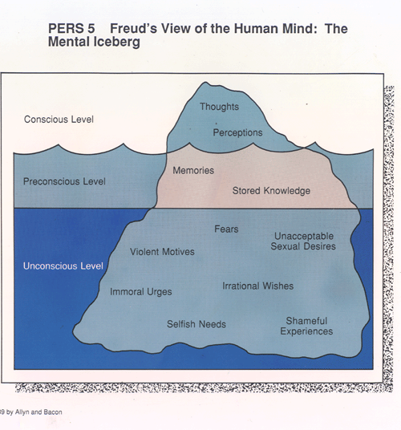

What do we think – do you think we have unconscious motives?

Freud was interested in child development and argued that our personality was based upon childhood experiences?

Freud observed five stages:

Oral stage – 0-2 years – babies put things in their mouth

Anal Stage – 2-4 years – Children fascinated by what comes out of their bodies

Phallic stage – 4-6 - Children notice sex differences and are aware of their own sexual organs.

Latent stage – 6- 12 - no outward sexual motivation for behaviour

Genital Stage – puberty onwards - interest in opposite sex starts at puberty (not no room for homosexuality or any variation on heterosexuality in Freud’s theories)

Other Psychoanalytic thinkers:

Carl Jung (1875-1961)

You might have heard of is the Collective Unconscious

Jung is famous for developing a model of personality based upon several “archetypes”

Personal Notes

Alfred Adler

Known for compensating and inferiority complex

Personal Notes

Erik Erikson

Known for lifetime stages of development

Do you think there are predicable stages in life?

Discussion notes
Thematic Apperception Tests (TAT)
Developed by Murray (1938)

For each of the two pictures you write a short story. In the story, write about:

- What is happening in the scene?
- Who is it?
- What has led to the situation?
- What is being thought?
- What is being wanted and by whom?
- What will happen?

TAT test 1
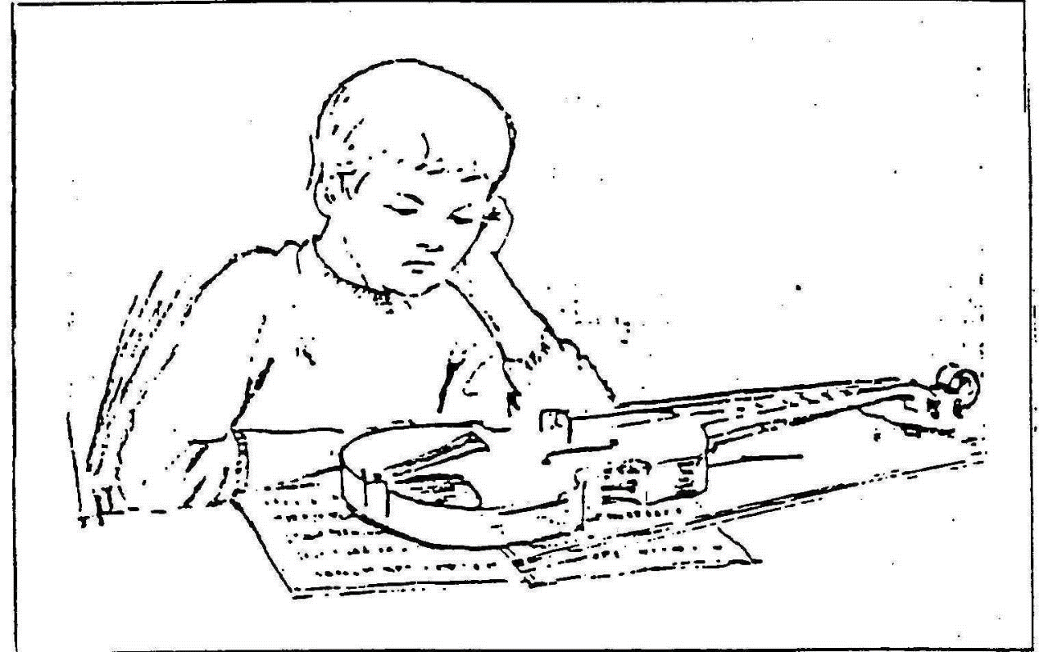

Write your story here:

TAT test 2
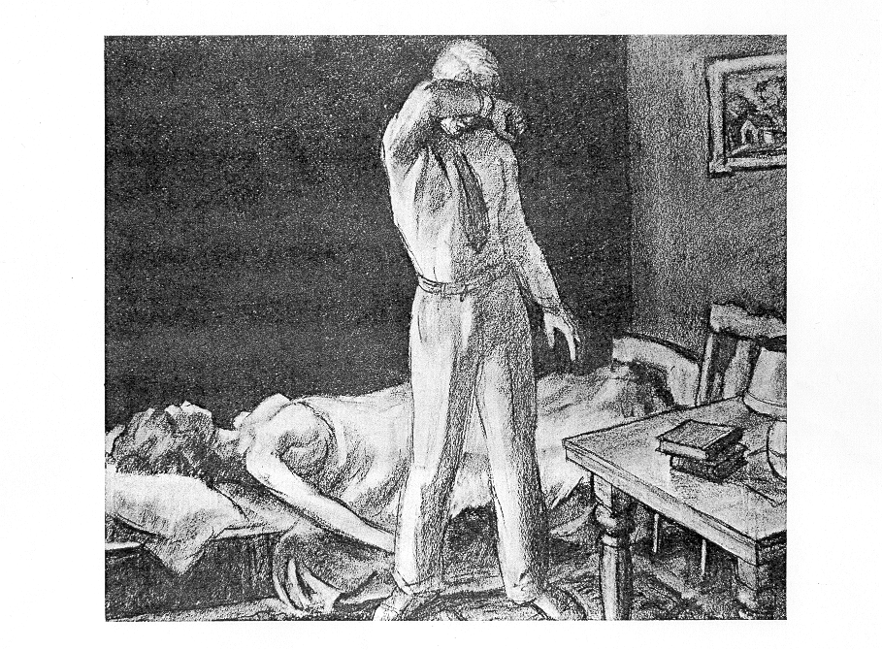
Write your story here:

Two of Freud’s famous case studies – do you think the implications are scientifically valid?

Case Studies (taken from McCleod, S.A Simply Psychology)
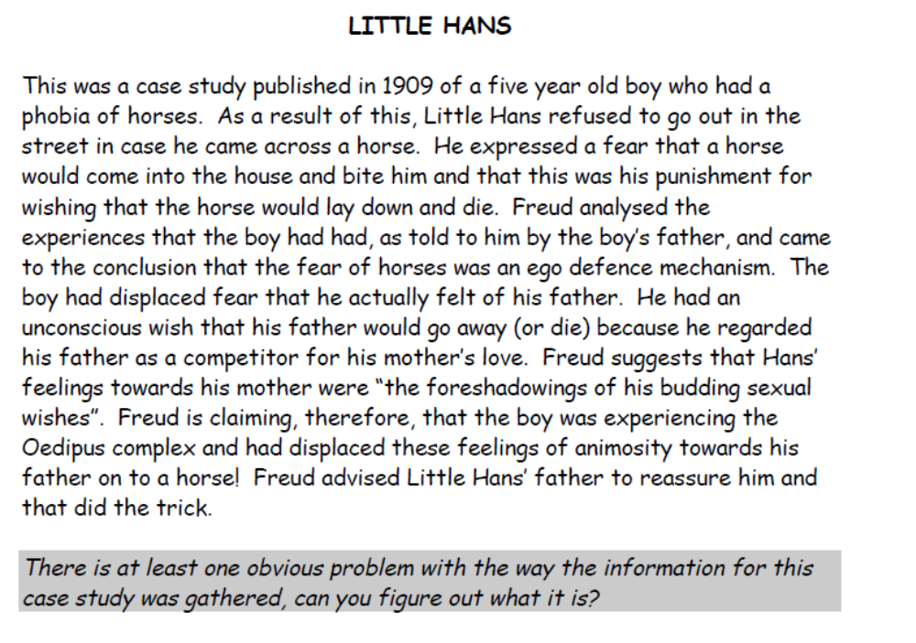
Any other thoughts?

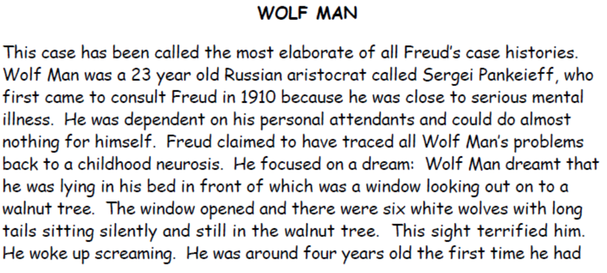
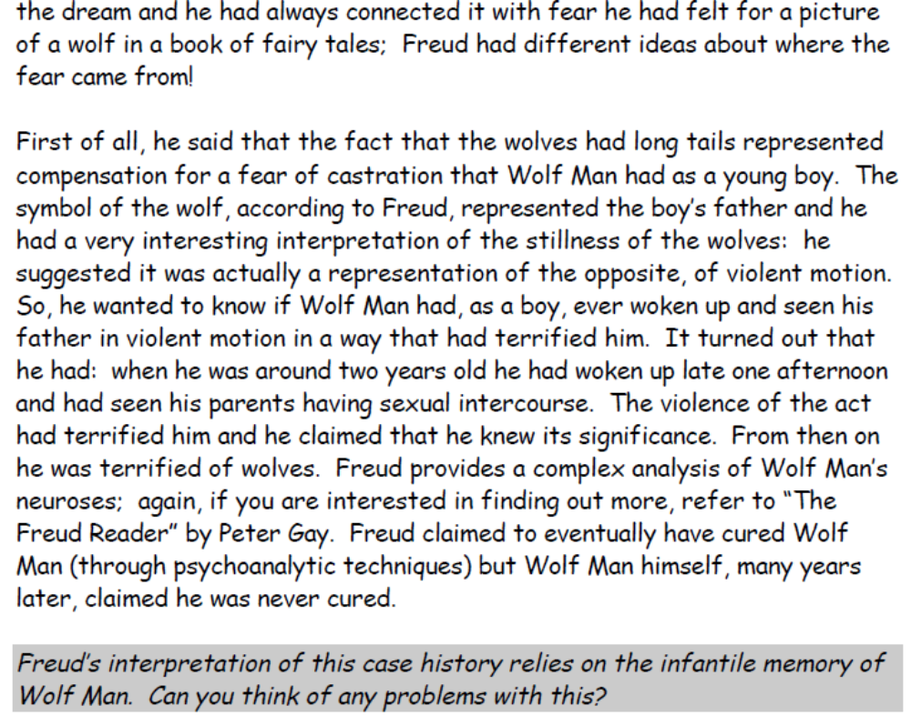
Your thoughts?
Week 12 Ethics and Psychological Research

This week we will examine the ethics of conducting an experiment.

Looking at the BPS code of ethics document – on the VLE and class hand out.

What would be our advice to anyone trying to replicate the ‘smelly tee shirt’ experiment we discussed 3 weeks ago?
What advice would we give about handling data and collecting personal information from the respondents?
Can we respond to these learning outcomes?

Level 3 | Unit title: Introduction to Psychology
Learning outcomes |  | Assessment criteria
This is what you will learn on the unit. |  | This is what you must be able to demonstrate that you can do in your assignment in order to achieve the unit.
The learner will: |  | The learner can:
- Understand the approaches/perspectives to psychology. |  | - Compare and contrast two psychological approaches/perspectives.
- Understand practical applications of two psychological perspectives |  | - Explain the practical applications of two psychological perspectives
- Understand the types of research methods used in psychology. |  | - Explain different types of research methods used in psychological research.  - Evaluate the role of ethical issues raised within psychological research.

Summary of assignment – full assignment on VLE
Task 1 – Psychological approaches (written response, word limit 1200 words)
Compare and contrast the Psychoanalytic (Psychodynamic) and Behavioural approaches in the understanding of human behaviour. (A.C. 1.1)
Explain the practical real life relevance of each approach (A.C. 2.1)
Task 2 – Psychological research methods (A.C.3.1)
In class we have discussed how we might try and discover what motivates students on the Access course and considered different approaches to research. Fill in the table on page 7 & 8 explain briefly the method and evaluate what the strengths and weaknesses are of each approach. (1000 Words)
Task 3 – Ethical issues in psychological research 500 words (A.C. 3.2)
In class we discussed the experiment (based upon the evolutionary approach) that the subconscious recognition of the smell of immune (major histocompatibility complex) using women smelling the tee shirts of men.
You are tasked with advising some students about the ethical requirements of conducting a replication of the experiment. Using the code of ethics, (PDF on the VLE) give advice to these students about some of the problems they might come up against if they were to undertake this project.

